|  |
| --- |
| Circle Language Spec: Commands |

## Private Objects in a Command Definition in a Diagram

This article demonstrates a situation of command objects.

This article illustrates how private objects in a command definition look in a diagram.

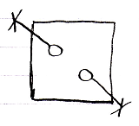

The square is a command definition. The circles inside of it are private objects. In diagram above the fact that they are private is displayed with the object line and the cross it ends with indicating, that you can not reference these objects from the outside.

The following picture is another possible expression of the private objects:

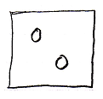

Because public object, parameters, always come with an indication of the parameter passing, you may not need to express the objects’ being private, because it would be obvious: if they do not have a parameter passing, then they are private.